Georgia Sugisandhea_535230080_Kelas C

1. Library building with division into parts (has-a) technique

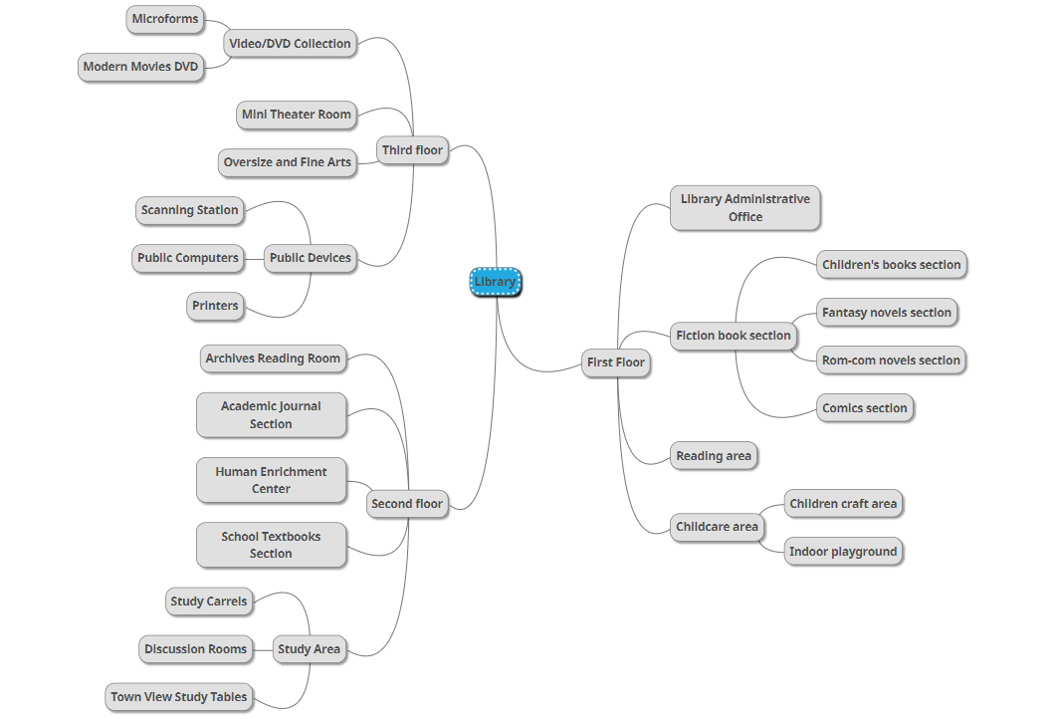

1. Books as collection of everyday object with specialization (is-a technique)

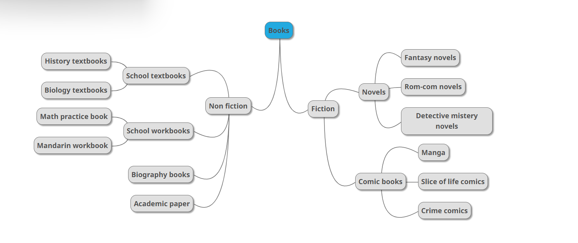

1. Interaction scenario for the organization from exercise 1

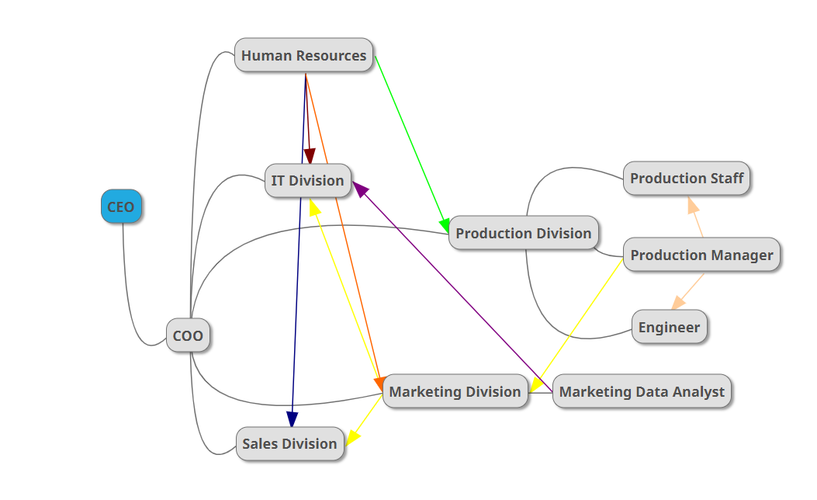

Notes:

* CEO will get all the info about the organization from the COO
* The Human Resources has connection to all division, for they are the one who auditions new staff members and sends them to the divisions they fit into
* Production manager has a connection to engineer to make sure all the production needs in the terms of tools and machines are met. Production manager has a connection to production staff to make sure the production is going well. Three of the objects is in the production division.
* Production manager has a connection to the marketing division to send messages of the production, advantage of disadvantage of their products so the marketing division is able to market them well.
* The marketing division has a connection to the sales division as to send messages of disadvantage and advantages they receive from production manager, so they can use them for sales purposes.
* Marketing data analyst from marketing division has a connection to it division to send the result of their analysis to be used in their website/app to improve customers satisfaction and promotion needs to maximize selling.